Tutorial 7

**Ex1: Given following diagram, write SQL query based on diagram given**

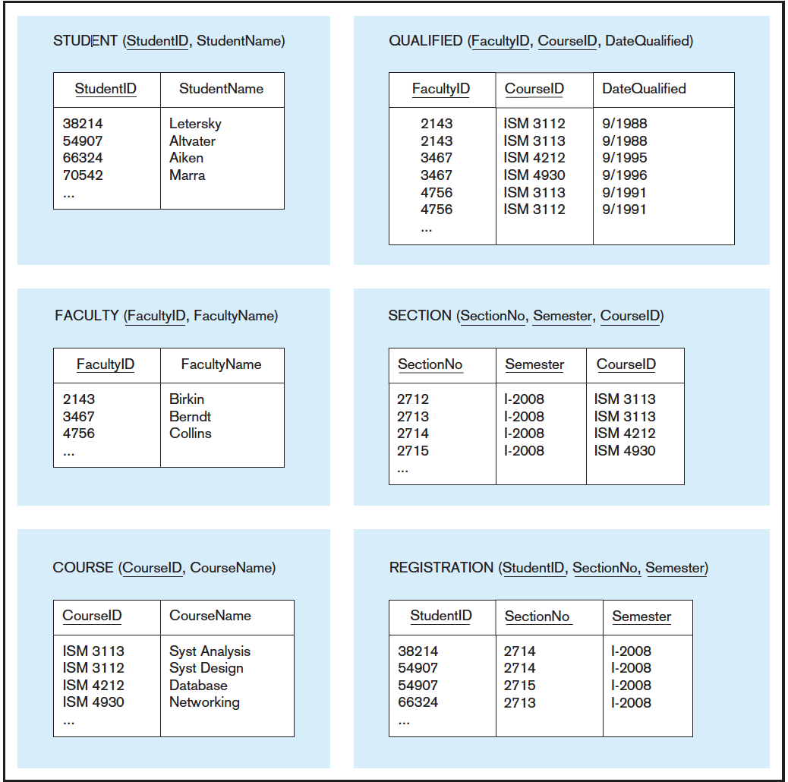

a. Display the course ID and course name for all courses with an ISM prefix.

b. Display courses information (CourseID and CourseName) for which Professor Berndt has been qualified.

c. Write an SQL query to answer the following question: Which faculty names are qualified to teach ISM 3113?

d. Write an SQL query to answer the following question: List all faculties qualified to teach ISM 3113 and not qualified to teach ISM 4930?

e. Write SQL queries to answer the following questions:

(1) How many students were enrolled in section 2714 during semester I-2008?

(2) How many students were enrolled in ISM 3113 during semester I-2008?

f. Write an SQL query to answer the following question:

Which students were not enrolled in any courses during semester I-2008?

**Ex 2: Write the SQL command for the following situation**

1. Add ‘MATH SCORE’ column (floating point number – length of 2) to the STUDENT table.
2. How many tutors have a status of Temp Stop? (Expected: 2)
3. Which tutors are active?
4. List the tutor information who took the certification class in January (formatted Cert date is month/day/year)

5. How many students were begin matched with someone in the first 5 months of the year 2008? (StartDate in the first 5 months of the year)

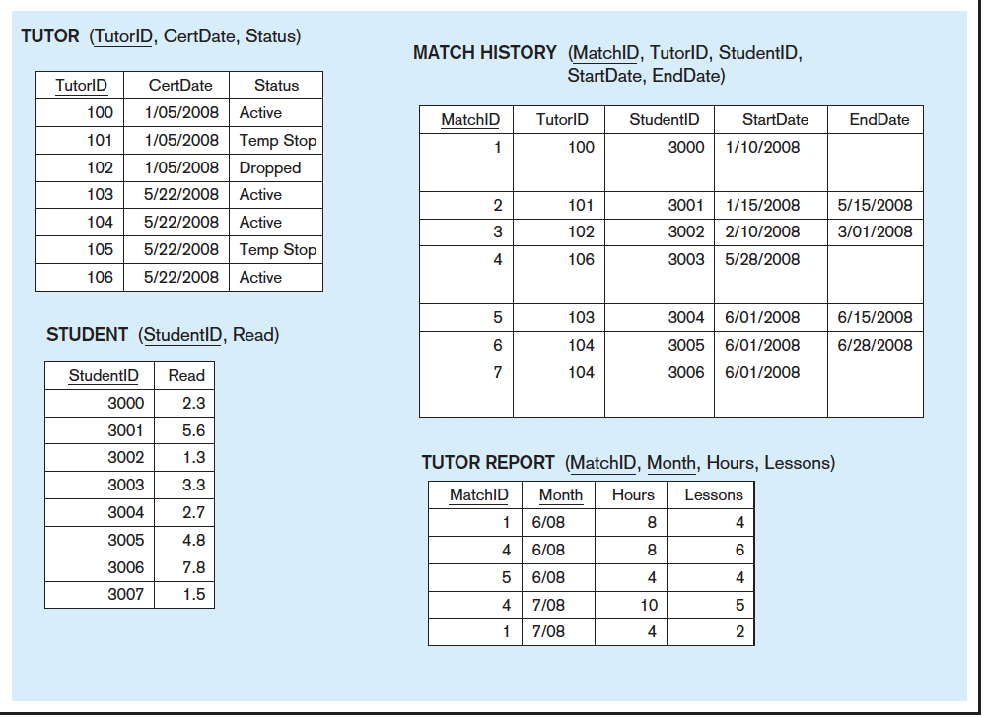6. List students ranking in Read Score descending? Which student has highest read score.